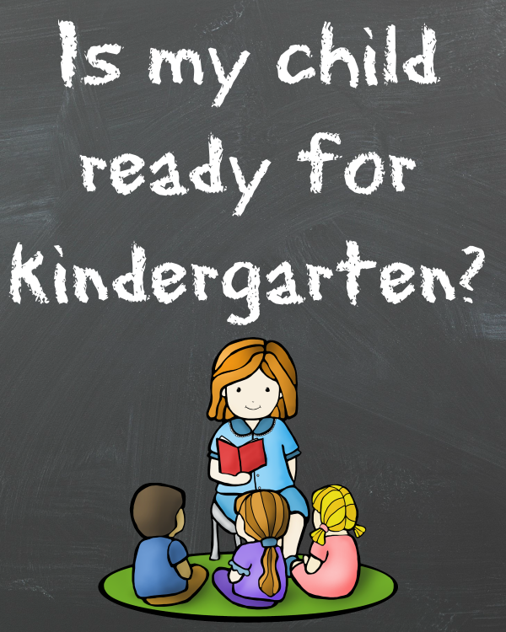

Kindergarten Readiness Checklist

Dear Parents and Preschool Teacher of _________________________________________,

Please fill out the attached checklist of kindergarten readiness questions. Our goal is to determine the best kindergarten start date for each individual child. The questions are designed for children ages 5 and 6. Kindergarten year launches a child’s school timeline from kindergarten to high school graduation, and we want to wisely and thoughtfully consider the optimum time to begin the school journey. We will be evaluating all of the components crucial to gaining a complete picture of the child through physical, social, emotional, and cognitive development assessments. Please answer to the best of your knowledge based upon your experience. Simply mark “N/A” on any questions not applicable to your time together. We appreciate your insightful feedback. Please return your completed form to the Plumas Christian School office. Call Shannon Little, principal of PCS, with any questions.

Thank You,

Shannon Little
(530)283-0415

Part 1: Concept Development
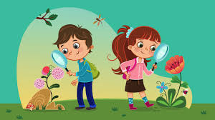
Does your child…
Criteria | Yes | No | Developing (notes)
recognize and/or name colors?
ask questions?
understand concepts such as in/out, on/off, front/back, up/down?
know body parts (head, shoulders, knees, etc.)?
demonstrate curiosity, persistence, and exploratory behavior?

Part 2: Physical Development
Can your child…

Criteria | Yes | No | Developing (notes)
walk on tiptoes?
jump in place?
balance on one foot?
hop on one foot?
jump forward?
skip?
throw and catch a ball/bean bag?

Part 3: Health and Safety
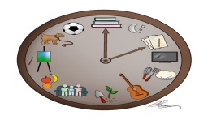
Is your child ready…

Criteria | Yes | No | Developing (notes)
for a set routine and schedule?
to follow simple safety rules?
to attend school 5 days a week?

Part 4: Shapes and Number Concept Development
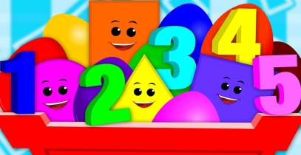
Does your child…

Criteria | Yes | No | Developing (notes)
know shapes?
write or recognize numbers 0-9?
match a number to a group of 5 or fewer items?

Part 5: Language
Does your child…

Criteria | Yes | No | Developing (notes)
talk in sentences?
follow through when you give him/her directions?
use descriptive language?
sing and/or recite nursery rhymes?
use conversational sentences?
use sentences that include 2 or more separate ideas?
pretend, create, and make up songs and stories?
talk about everyday experiences?
ask questions about how things work in the world around him/her?
express his/her ideas so that others can understand?
tell or retell stories?
speak in a way that is understood by others most of the time?

Part 6: Reading
Does your child…

Criteria | Yes | No | Developing (notes)
recognize his/her first name in print?
look at books or pictures on his/her own?
pretend to read books by reading the pictures?
name letters of the alphabet?
express curiosity about words?

Part 7: Writing/Fine Motor Skills
Does your child…

Criteria | Yes | No | Developing (notes)
attempt to draw real-life objects?
write his/her first name?
express curiosity about writing?
write letters of the alphabet?
hold a pencil and use scissors? (fine motor skills)

Part 8: Social and Emotional Development
Does your child…

Criteria | Yes | No | Developing (notes)
use words to solve problems when angry or frustrated?
use words such as “please”, “thank you”, and “excuse me”?
attempt new tasks knowing it’s okay to make a mistake?
do things for himself/herself (dress self, put toys away, take care of toilet needs?
have success in taking turns and sharing?
interact appropriately with peers?
ask for help when necessary?
stay with an activity to completion (finish a picture, build, etc.)?
interact appropriately with adults?
use words to express needs and wants?
separate from a parent or caregiver without getting overly upset?
pay attention for 5-10 minutes to a task an adult is leading?

Printed Name:_________________________
Signature:____________________________
Date:______________________

Thank You for Your Time

